|  |
| --- |
| popCap |
| Plants vs. Zombies |
| Tower Defense |
| First Version  All work Copyright © 2009 by PopCap Games.  All rights reserved. |
| **George Fan and Laura Shigihara** |
| **Documented by Andre Lemos - 300930438** |



|  |
| --- |
| May 5th 2009 |

Table of Contents

Table of Contents 2

Version History 3

**I-** Game Overview 4

**II-** Game Play Mechanics 4

**III-** Camera 4

**IV-** Controls 4

**V-** Saving and Loading 5

**VI-** Interface Sketch 5

**VII-** Menu and Screen Descriptions 6

**VIII-** Game World 6

**IX-** Levels 7

**X-** Game Progression 7

**XI-** Characters 10

**XII-** Non-player Characters 12

**XIII-** Enemies 12

**XIV-** Items 13

**XV-** Scoring 14

**XVI-** Mini-games 14

**XVII-** Bonuses 15

**XVIII-** Sound Index 15

**XIX-** Story Index 16

**XX-** Future Features 16

# Version History

# Game Overview

Prepare for the battle of your life, the zombies invade the earth and the only way to save your life and your family lives, you need to use the plants. The plants will give your life to save you, they will be your soldier. But the plants have a limitation, they cannot move, so you need to choose strategy position for your plants. And remember you who going to decide where the plants will stay. Because if put your plants in the wrong position the zombie will be free to catch you. Are prepared for the win this fight with your plants?

Let's go! Plants vs. Zombies start now!

# Game Play Mechanics

The plants vs. Zombie is tower defend. The mechanics is simple; the player need to position her plants to kill the wave of zombies. The player need to define what is the best plants to defeat the zombie base on the zombie character and stage of the game.

The player has 35 option of plants to choose and 25 different types of zombies to defeat.

# Camera

The game user a Static Camera, the camera does not change position.

# Controls

The game uses a simple point and click interface, for a computer they only required a mouse. The game work in Tables and Smartphone, so for play only need click.

Left button mouse only you need to play.

 Table and Smartphone only need to touch in the scree.

# Saving and Loading

The game can be saved any time. The game saves in local application, and the game need some loading when the start, pass the level and save.

# Interface Sketch

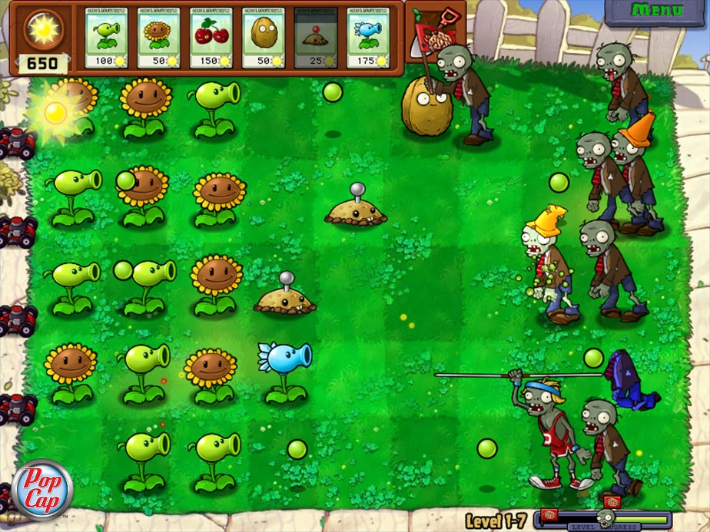

# Menu and Screen Descriptions

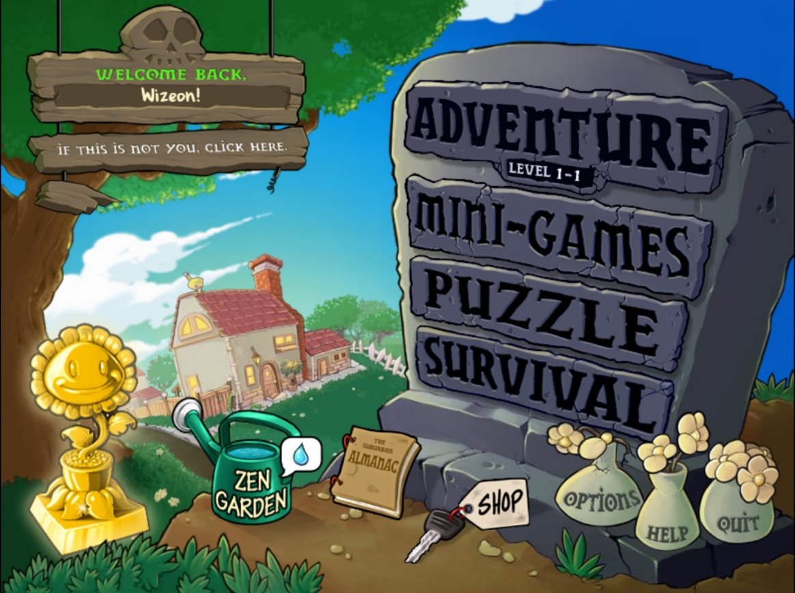

The menu divides for Adventure, Mini-Games, Puzzle, and Survival. The menu has other functionality such as shop and Zen garden. The menu also has the options and help. First part of menu is the game; the player can select how adventure he only to play. Second part of the menu is for the player expend or money. Third part is for configuration.

# Game World

The Plants vs. Zombie happen in a farm, the farmer discovery the world starts to be attacked for Zombie. He recruits her plants to protect her family and her farm. This moment the plants is the only who can stop the zombie attack.

# Levels

The plants vs. zombies have fifteen levels. The game divide in five stages: one day, second night, third pool, fourth fog, fifth roof. In fact, every stage has ten levels.

1. Stage Day: 1-1, 1-2, 1-3, 1-4, 1-5, 1-6, 1-7, 1-8, 1-9, 1-10.
2. Stage Night: 2-1, 2-2, 2-3, 2-4, 2-5, 2-6, 2-7, 2-8, 2-9, 2-10.
3. Stage Pool: 3-1, 3-2, 3-3, 3-4, 3-5, 3-6, 3-7, 3-8, 3-9, 3-10.
4. Stage Fog: 4-1, 4-2, 4-3, 4-4, 4-5, 4-6, 4-7, 4-8, 4-9, 4-10.
5. Stage Roof: 5-1, 5-2, 5-3, 5-4, 5-5, 5-6, 5-7, 5-8, 5-9, 5-10.

# Game Progression

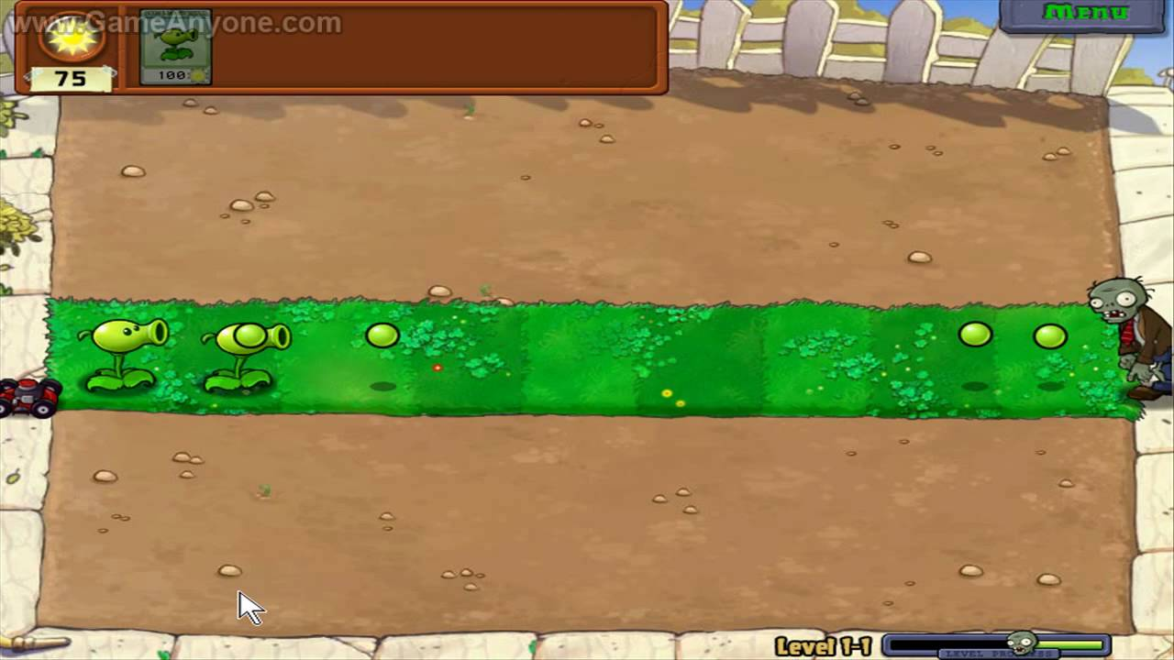

In the level 1-1 in Day stage, the game starts simple, only need put some plants, and kill the wave of zombies. In fact, only need to protect is one row.

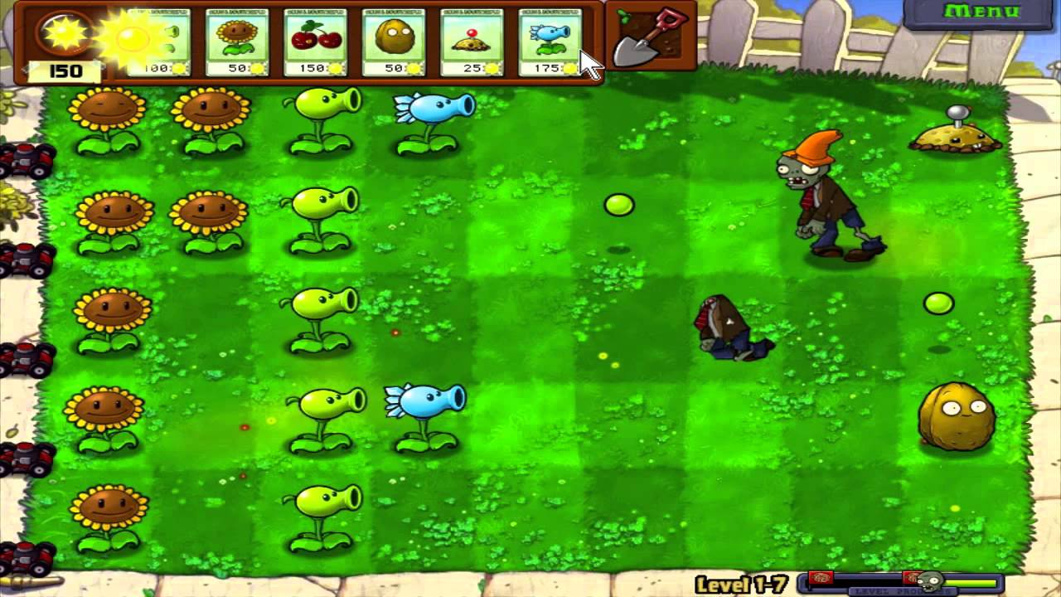

In the level 1-7, the game became more difficult and zombie more powerful, and you need to put more plants. Therefore, the game provides more powerful plants to combat the zombies. And now the player needs to protect 5 rows at the same time, and he need to plant more Sunflower who goon give sun to buy more plants. The game start to be more challenge.

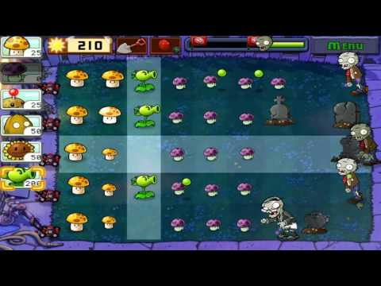

In the level 2-2 stage night, the game change, they give different stage who has different zombies and plants. Therefore, the player need to learn how to use the new plants.

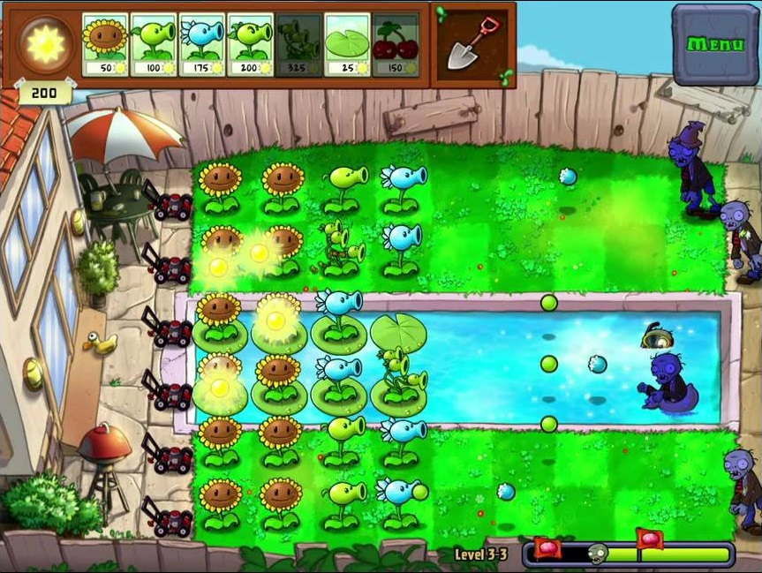

Level 3-3 stage Pool.

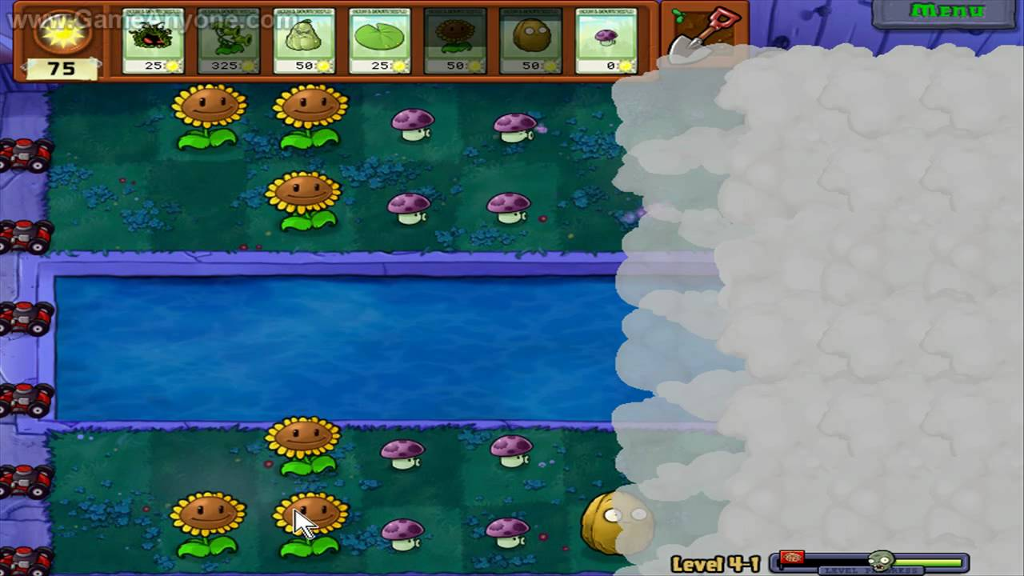

Level 4-1 stage fog.

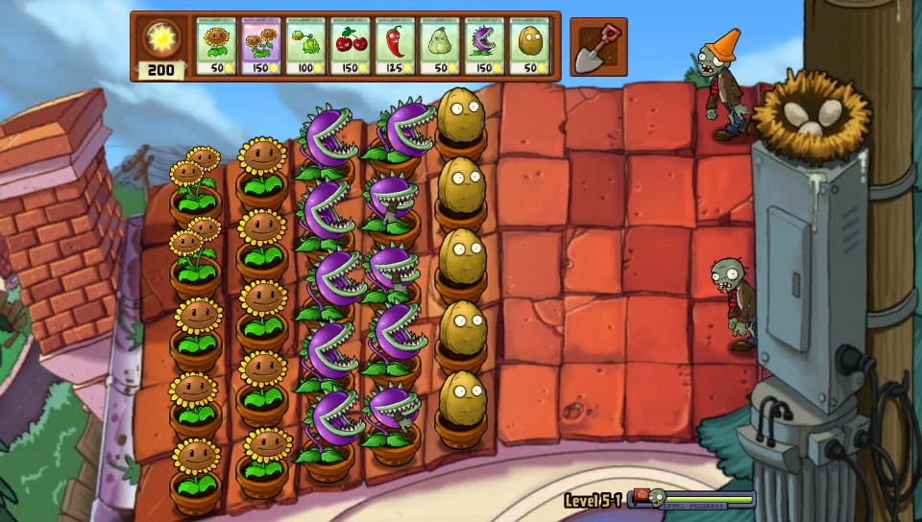

In level 5-1 stage roof.

The game progress in this way, every stage has different challenge for eliminate zombie. In fact, zombie became more powerful every stage, and the wave grow up. The player wins new plants with different ability, and he need to select eight to fight. The player can make combination who he defines better for defeat the zombies.

# Characters

|  |  |  |  |  |  |  |  |
| --- | --- | --- | --- | --- | --- | --- | --- |
| **DAY**  **Stage** | Peashooter1 | Sunflower1 | Cherry Bomb1 | Wall-nut1 | Potato Mine1 | Snow Pea1 | Chomper1 |
| **Name** | **Peashooter** | **Sunflower** | **Cherry Bomb** | **Wall-nut** | **Potato Mine** | **Snow Pea** | **Chomper** |
| **Cost** | **100** | **50** | **150** | **50** | **25** | **175** | **150** |
| **Damage** | **Normal** | **Zero** | **Massive** | **Zero** | **Massive** | **Normal + Slow** | **Massive** |

|  |  |
| --- | --- |
| **DAY**  **Stage** | Repeater1 |
| **Name** | **Repeater** |
| **Cost** | **200** |
| **Damage** | **Median** |

|  |  |  |  |  |  |  |  |
| --- | --- | --- | --- | --- | --- | --- | --- |
| **Night**  **Stage** | Puff-shroom1 | Sun-shroom1 | Fume-shroom1 | Hypno-shroom1 | Scaredy-shroom1 | Ice-shroom1 | Doom-shroom1 |
| **Name** | **Puff-shroom** | **Sun-shroom** | **Fume-shroom** | **Hypno-shroom** | **Scaredy-shroom** | **Ice-shroom** | **Doom-shroom** |
| **Cost** | **0** | **25** | **75** | **75** | **25** | **75** | **125** |
| **Damage** | **Normal** | **Zero** | **Normal+ shield** | **Make Zumbi** | **Normal** | **Freezes** | **Massive** |

|  |  |  |  |  |  |  |  |
| --- | --- | --- | --- | --- | --- | --- | --- |
| **Pool**  **Stage** | Lily Pad1 | Squash1 | Threepeater1 | Jalapeno1 | Spikeweed1 | Torchwood1 | Tall-nut1 |
| **Name** | **Lily Pad** | **Squash** | **Three-peater** | **Jalapeno** | **Spike-weed** | **Torch-wood** | **Tall- nut** |
| **Cost** | **25** | **50** | **325** | **125** | **100** | **175** | **125** |
| **Damage** | **Zero** | **Massive** | **Normal X3** | **Massive** | **Normal + Slow** | **Improve Damage** | **Zero** |

|  |  |  |  |  |  |  |  |
| --- | --- | --- | --- | --- | --- | --- | --- |
| **Fog**  **Stage** | Sea-shroom1 | Cactus1 | Blover1 | Split Pea1 | Starfruit1 | Pumpkin1 | Magnet-shroom1 |
| **Name** | **Sea-shroom** | **Cactus** | **Blover** | **Split Pea** | **Starfruit** | **Pumpkin** | **Magnet-shroom** |
| **Cost** | **0** | **125** | **100** | **125** | **125** | **125** | **100** |
| **Damage** | **Normal** | **Media** | **Zero** | **Normal X2** | **Normal** | **Zero** | **Zero** |

|  |  |  |  |  |  |  |  |
| --- | --- | --- | --- | --- | --- | --- | --- |
| **Roof**  **Stage** | Cabbage-pult1 | Flower Pot1 | Kernel-pult1 | Coffee Bean1 | Umbrella Leaf1 | Marigold1 | Melon-pult1 |
| **Name** | **Cabbege-Pult** | **Flower Pot** | **Kernel-Pult** | **Coffee- Bean** | **Umbrella-Leaf** | **Marigold** | **Melon-Punt** |
| **Cost** | **100** | **25** | **100** | **75** | **100** | **50** | **300** |
| **Damage** | **Normal** | **Zero** | **Normal + Slow** | **Massive** | **Normal** | **Zero** | **Massive** |

|  |  |  |  |  |  |  |  |
| --- | --- | --- | --- | --- | --- | --- | --- |
| **Upgrade** | Gatling Pea1 | Twin Sunflower1 | Gloom-shroom1 | Winter Melon1 | Gold Magnet1 | Cob Cannon1 | Spikerock1 |
| **Name** | **Gatling Pea** | **Twin Sunflower** | **Gloom-Shroom** | **Winter Melon** | **Gold Magnet** | **Cob Cannon** | **Spike-rock** |
| **Cost** | **250** | **150** | **150** | **200+300** | **50+100** | **500+200** | **125** |
| **Damage** | **Massive** | **Zero** | **Massive** | **Massive** | **Zero** | **Massive** | **Median** |

# Non-player Characters



The Sun is controlled for computer and pops up on the screen at random. The sun is like the money for the game, the player needs to get the sun in order to buy plants.

# Enemies

|  |  |  |  |  |  |
| --- | --- | --- | --- | --- | --- |
| **Day**  **Stage** | Zombie1 | Flag Zombie1 | Conehead Zombie1 | Pole Vaulting Zombie1 | Buckethead Zombie1 |
| **Name** | **Zombie** | **Flag Zombie** | **Cone-head Zombie** | **Pole Vaulting Zombie** | **Bucket-head**  **Zombie** |
| **Power** | **1 -10** | **1 - 10** | **2 -10** | **1 – 10 + Jump** | **3-10** |

|  |  |  |  |  |  |
| --- | --- | --- | --- | --- | --- |
| **Night**  **Stage** | Newspaper Zombie1 | Screen Door Zombie1 | Football Zombie1 | Dancing Zombie2 | Backup Dancer2 |
| **Name** | **New-paper Zombie** | **Screen-Door Zombie** | **Football Zombie** | **Dancing Zombie** | **Backup**  **Zombie** |
| **Power** | **1 -10** | **3 - 10** | **4 -10** | **1 – 10 +Group** | **1 – 10 +Group** |

|  |  |  |  |  |  |
| --- | --- | --- | --- | --- | --- |
| **Pool**  **Stage** | Ducky Tube Zombie1 | Snorkel Zombie1 | Zomboni1 | Zombie Bobsled Team1 | Dolphin Rider Zombie1 |
| **Name** | **DuckyTube Zombie** | **Snorkel Zombie** | **Zomboni** | **Zombie Bobsled** | **Dolphin Rider**  **Zombie** |
| **Power** | **1 -10** | **1 – 10+Avoid** | **4-10+Group** | **1 – 10 +Group** | **3– 10 +Avoid** |

|  |  |  |  |  |  |
| --- | --- | --- | --- | --- | --- |
| **Fog**  **Stage** | Jack-in-the-Box Zombie1 | Balloon Zombie1 | Digger Zombie1 | Pogo Zombie1 | Zombie Yeti1 |
| **Name** | **Jack Box Zombie** | **Balloon Zombie** | **Digger Zombie** | **Pogo**  **Zombie** | **Zombie Yeti** |
| **Power** | **2 -10** | **1 – 10+Avoid** | **5-10** | **2 – 10 + Jump** | **7– 10 +Avoid** |

|  |  |  |  |  |  |
| --- | --- | --- | --- | --- | --- |
| **Roof**  **Stage** | Bungee Zombie1 | Ladder Zombie1 | Catapult Zombie1 | Gargantuar1 | Dr. Zomboss1 |
| **Name** | **Bungee Zombie** | **Ladder Zombie** | **Catapult Zombie** | **Gargantuar** | **Dr. Zomboss** |
| **Power** | **1-10+Avoid** | **4–10** | **6 - 10** | **8 -10** | **10 -10 + Boss** |

# Items

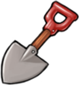**Shovel is to remove a plant.**

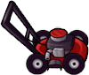**Lawn Mower is extra defender.**

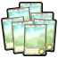**Seed packets id the plants card.**

**Present is a Bonus**

# Scoring

The game gives a player a Trophy when he completed the stage. The player need to win 5 trophies to win the game.



The player also can win Money bag. The bag only gives money for buying some extra utilities, who not affect the real game.



# Mini-games

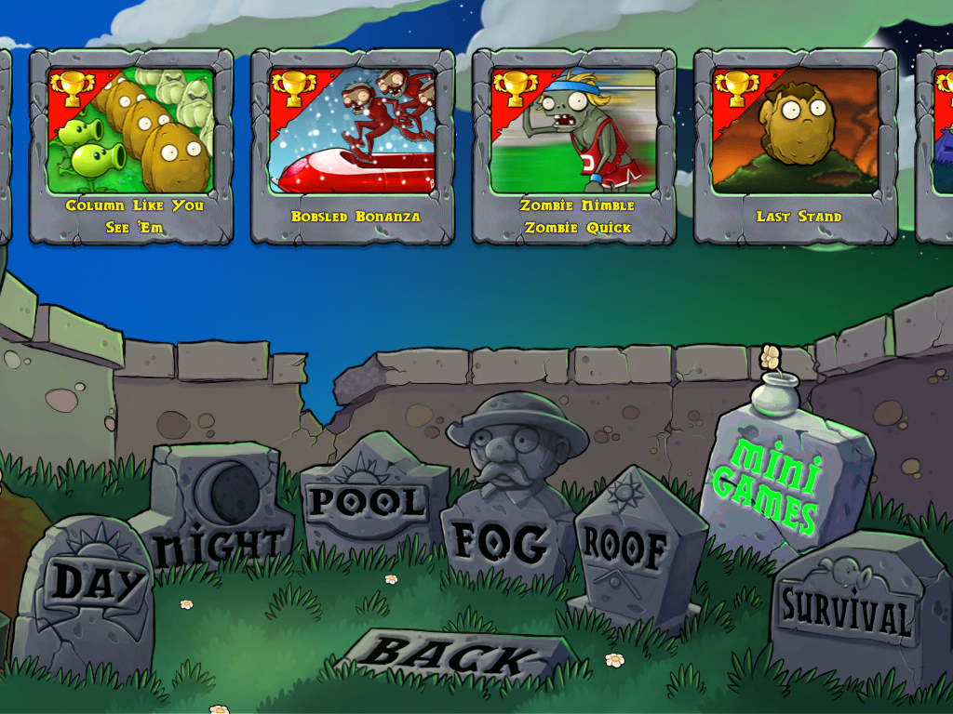

The mini-games is for win extra trophies, they will not affect in the real game, so It is funny part. The idea is entertainment the player for extra stage and extra challenge**.**

# Bonuses

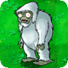

The Zombie Yeti is a bonus because he has the power to scape. If the player killed the Yeti, he going to win bonus item or special unlock plant.

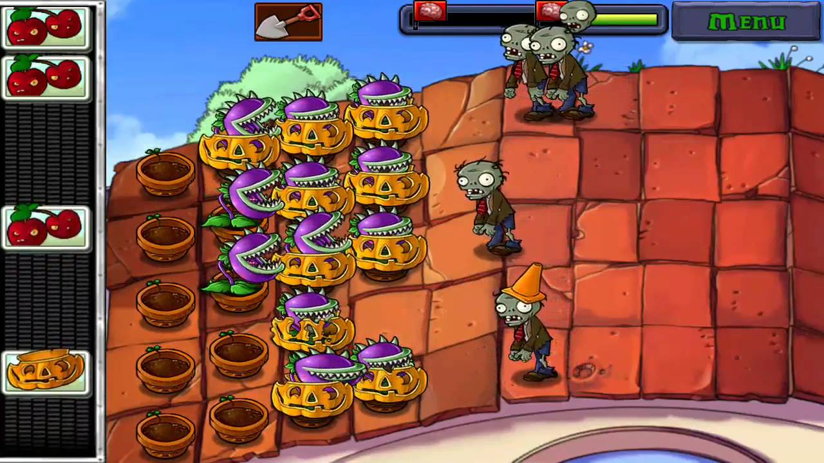

In Every stage, the gamer has bonus stage. That mean the gamer has five bonuses and it is look like the image. The player going to win randomly plants, he need to figure a way to win.

# Sound Index

The soundtrack is created for Laura Shigihara. She used a combination of many sounds such as “Big Band”, “Loonboon”, “Ultimate Battle” and “Brainiac Maniac”. She created music only for the game, the music is “Zombies on Your Lawn”. Laura has help for Danny Elfman for melodic part.

# Story Index

The world has been attacked by zombies, the leader of the zombies is Dr. Zomboss. In a farm, the farmer created special plants to fight the zombies. Therefore, the war between plants vs. Zombies start because the farmer and his family are food for the zombies, and the plants are the protection of the farmer. Many plants will lose their lives, but all plants are warrior they are prepared to win this battle.

# Future Features

The Plant vs. Zombies 2 is coming, and be excite because we going to build a counter strike for Plant vs. Zombies.